## **Week 4 Homework Submission File: Linux Systems Administration**

### **Step 1: Ensure/Double Check Permissions on Sensitive Files**

1. **Permissions on /etc/shadow should allow only root read and write access.**  
   * Command to inspect permissions:

ls -l etc/shadow

* + Command to set permissions (if needed):

sudo chmod 600 /etc/shadow

1. **Permissions on /etc/gshadow should allow only root read and write access.**  
   * Command to inspect permissions:

ls -l etc/gshadow

* + Command to set permissions (if needed):

sudo chmod 600 /etc/gshadow

1. **Permissions on /etc/group should allow root read and write access, and allow everyone else read access only.**  
   * Command to inspect permissions:

ls -l etc/group

* + Command to set permissions (if needed)

Sudo chmod 644 /etc/group

1. **Permissions on /etc/passwd should allow root read and write access, and allow everyone else read access only.**  
   * Command to inspect permissions:

ls -l etc/passwd

* + Command to set permissions (if needed):

Sudo chmod 644 /etc/password

### **Step 2: Create User Accounts**

1. **Add user accounts for sam, joe, amy, sara, and admin.**  
   * Command to add each user account (include all five users):

Sudo adduser sam

Sudo adduser joe

Sudo adduser sara

Sudo adduser admin

1. **Ensure that only the admin has general sudo access.**  
   * Command to add admin to the sudo group:

Sudo usermod -aG sudo admin

### **Step 3: Create User Group and Collaborative Folder**

1. **Add an engineers group to the system.**  
   * Command to add group:

sudo addgroup engineers

1. **Add users sam, joe, amy, and sara to the managed group.**  
   * Command to add users to engineers group (include all four users):

sudo usermod -aG engineers joe

sudo usermod -aG engineers amy

sudo usermod -aG engineers sam

sudo usermod -aG engineers sara

1. Create a shared folder for this group at /home/engineers.  
   * Command to create the shared folder:

sudo mkdir engineers

1. Change ownership on the new engineers' shared folder to the engineers group.  
   * Command to change ownership of engineer's shared folder to engineer group:

sudo chgrp -R engineers /home/engineers

### **Step 4: Lynis Auditing**

1. Command to install Lynis:

Sudo apt-get install -y lynis

1. Command to see documentation and instructions:

man lynis audit system

1. Command to run an audit:

lynis audit system

1. Provide a report from the Lynis output on what can be done to harden the system.  
   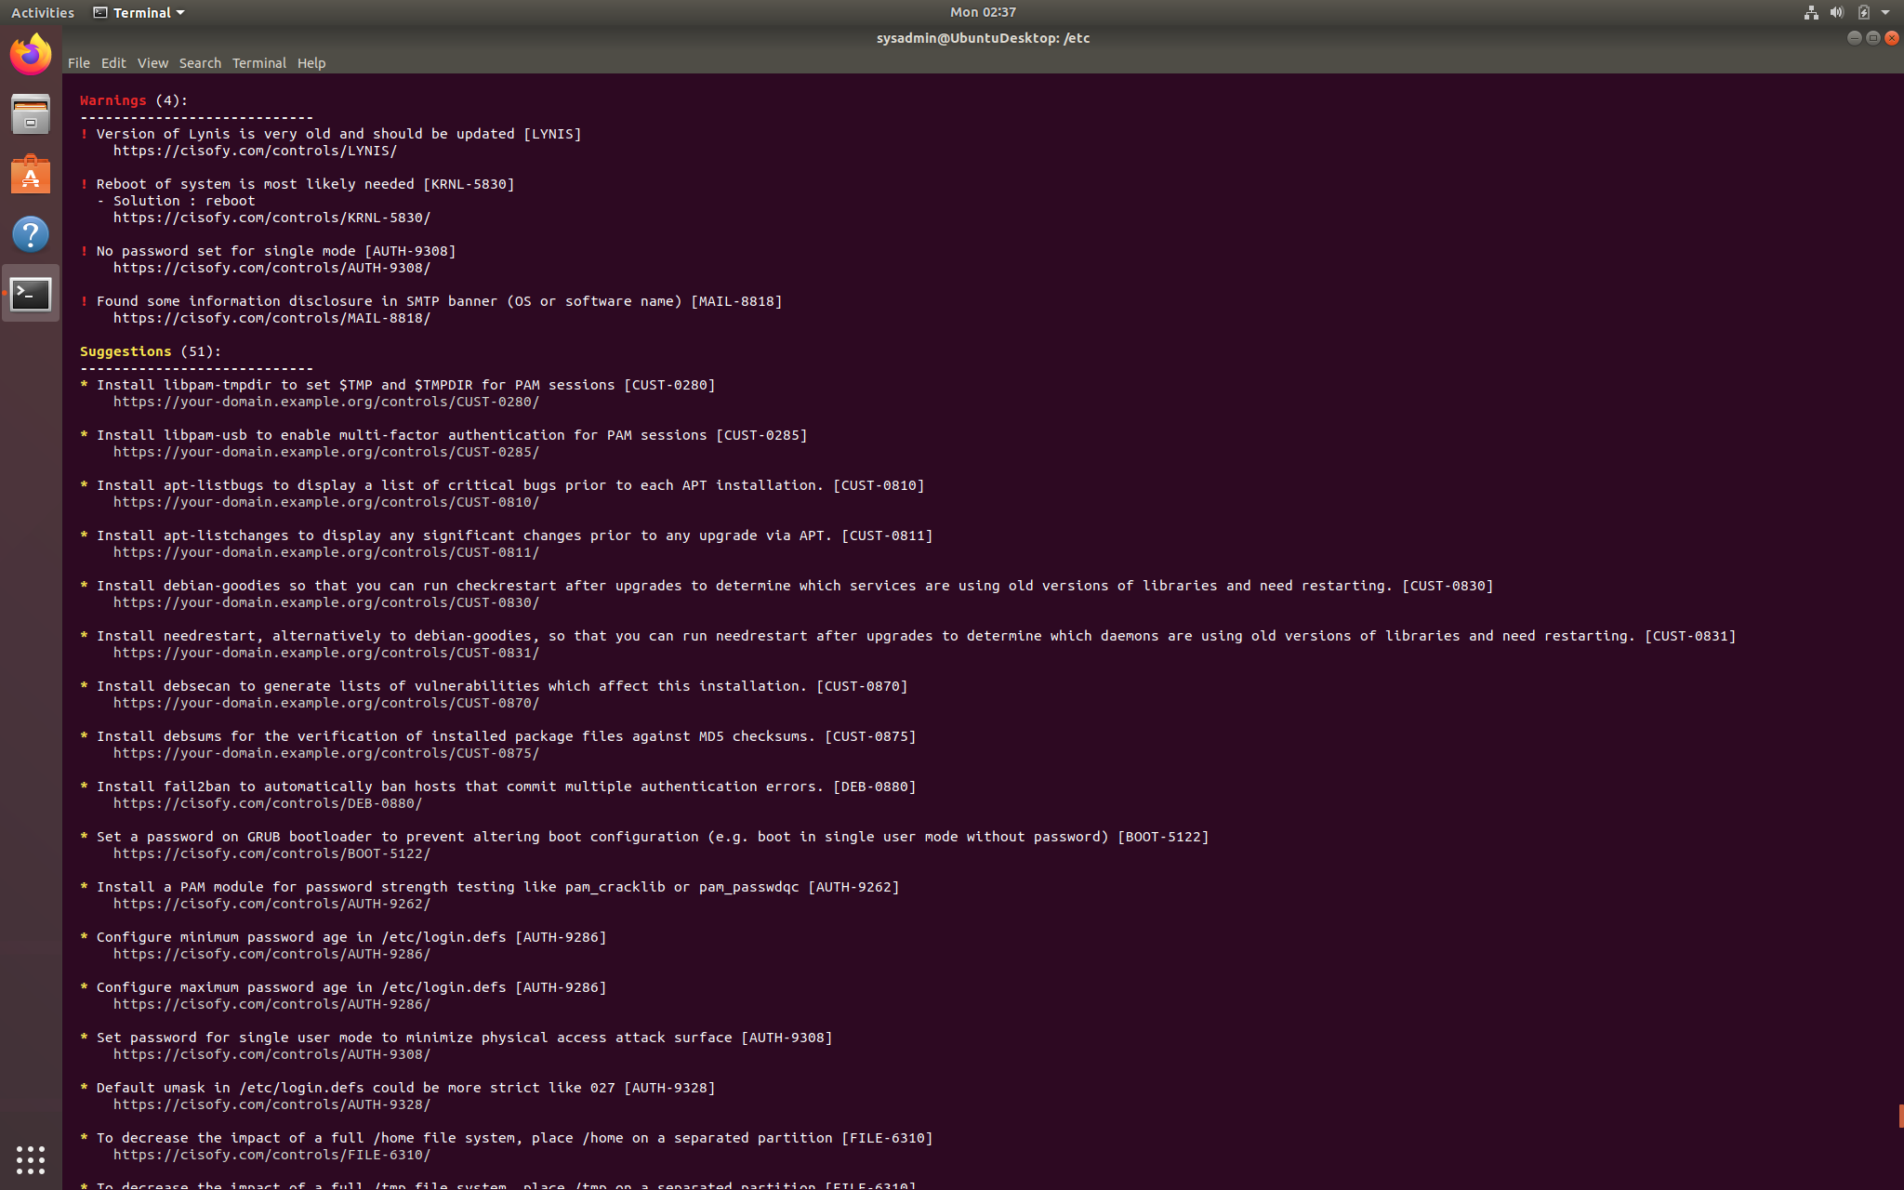
   * Screenshot of report output:

### **Bonus**

1. Command to install chkrootkit:  
     
   Sudo apt-get install -y chkrootkit
2. Command to see documentation and instructions:

man chkrootkit

1. Command to run expert mode

sudo chkrootkit -x

1. Provide a report from the chrootkit output on what can be done to harden the system.  
   * Screenshot of end of sample output: